Classification – SVM

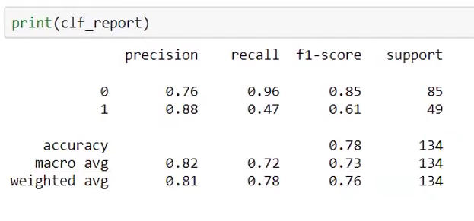

Precision
Q: When the model predicts a customer will NOT purchase, how often is it correct?
A: The model is correct 76% of the time when predicting non-purchasers.
Q: When the model predicts a customer WILL purchase, how often is it correct?
A: The model is correct 88% of the time when predicting purchasers.

Recall
Q: Out of all customers who actually did NOT purchase, how many did the model successfully identify?
A: The model correctly identified 96% of actual non-purchasers.
Q: Out of all customers who actually purchased, how many did the model successfully identify?
A: The model correctly identified only 47% of actual purchasers.
Client Insight: The model is missing more than half of the actual purchasers.

F1-Score
Q: How well does the model perform overall for non-purchasers by balancing correctness and coverage?
A: The model achieved an overall performance score of 85% for non-purchasers.
Q: How well does the model perform overall for purchasers by balancing correctness and coverage?
A: The model achieved an overall performance score of 61% for purchasers.

Support
Q: How many non-purchasing customers were evaluated?
A: The evaluation included 85 non-purchasing customers.
Q: How many purchasing customers were evaluated?
A: The evaluation included 49 purchasing customers.

Accuracy
Q: Overall, how often does the model make the correct prediction?
A: The model correctly predicts customer behavior 78% of the time.

Macro Average
Q: What is the model's average performance when purchasers and non-purchasers are given equal importance?
A: The model achieved:
- 82% Precision
- 72% Recall
- 73% F1-Score
This indicates moderate overall performance when treating both classes equally.

Weighted Average
Q: What is the model's overall performance after considering the actual distribution of purchasers and non-purchasers?
A: The model achieved:
- 81% Precision
- 78% Recall
- 76% F1-Score
This reflects the model's real-world performance on the dataset.

